Project: Woodson Park Academy & YMCA-ELC
Week Ending: October 25th, 2019

THIS WEEK:
- Foundations wall pours
- Storm Line B completed
- Lower level MEP’s continued
- Waterproofing at retaining wall
- Retaining wall backfill started

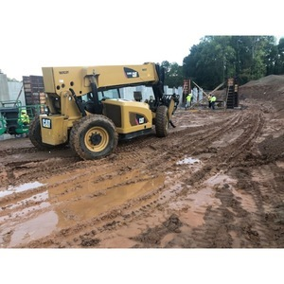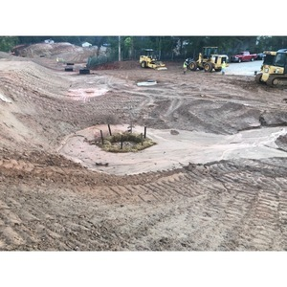

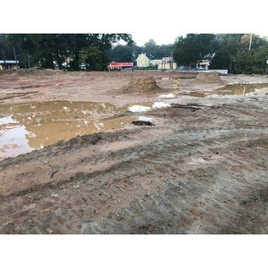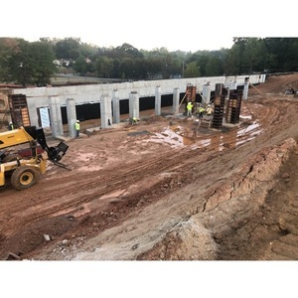

NEXT WEEK – October 28 thru November 1:
- Continue underslab ME
- Start slab prep at kitchen area

PAYMENT STATUS:
- Gmp#1 $3,703,488.00
  - Paid to date amount $1,469,778.75
- GMP#2 $28,686,295.00
  - Paid to date amount $0.00

SCHEDULED DATE OF SUBSTANTIAL COMPLETION
- WPA – September 28, 2020
- YMCA-ELC - September 16, 2020

PREPARED BY:
- Matt Dauber, Carroll Daniel Construction Co.

